Babble

Overview
Babble is a real time interactive news feed, designed for consumption by second screen devices, that accompanies the content being displayed on the primary television screen.

Content of the feed
The feed consists of interactive events, comments, stories, polls, coupons. The viewer interacts with each of these events and the results of the interaction are sent back to the Babble service.

How to consume the feed
New events will appear in the feed as the content on the primary television screen changes. A new event should be consumed from the feed as quickly as possible in order to keep the feed in sync with the primary screen.

Layout of the feed events
Each babble event consists of a header and body. The header is consistent between every type of event. The header should be used for displaying different types of events in a consistent manner.

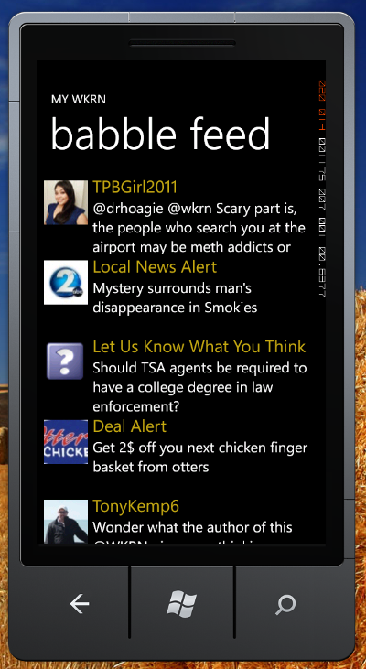

The body is custom for each type of babble event. The body should be used for displaying a customized interactive screen for that event. For instance, the body of a polling event consists of the valid responses, the number of votes cast, and the percentage of votes cast for each response.

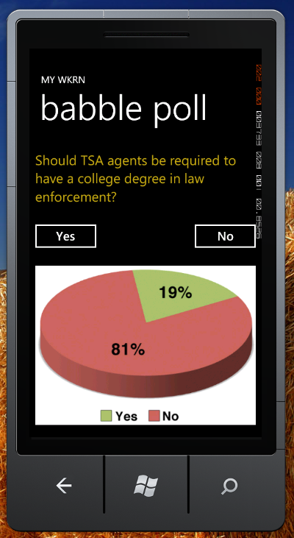

Feed Service

The feed service is a Rest service for retrieving events and posting responses at
address: http://prod.bti.tv/babble/babble.svc.

The folling urls can be used to retrieve the last 10 events from a customers babble feed in either xml or json.

xml/babble/{customerid}
json/babble/{customerid}

The folling urls can be used to retrieve the any new events since the current event.

xml/babble/{customerid}/{eventid}
json/babble/{customerid}/{eventid}

The folling urls can be used for reporting customer responses.

xml/bobble/{customerid}/{eventid}
json/bobble/{customerid}/{eventid}

